1. Source Code:

clc;

clear;

w=randn(40000,1);ry=xcorr(w,100);T=-30:30;

f = (0:length(ry)-1)/length(ry);

autocorrelation=2.778*0.8.^abs(T);

PSD=1./(1.64-1.6.*cos(2*pi*f));

decay=0.8;t=0:30;h=exp(log(decay)*t);

Ry=xcorr(conv(w,h),100);

Sy=abs(fft(Ry));

figure(1);

plot(1:length(Ry),Ry);

title('autocorrelation');

grid on;

figure(2);

plot([zeros(1,70) autocorrelation zeros(1,70)]);

title('theoretical autocorrelation');

grid on;

figure(3)

plot(1:length(Sy),abs(Sy));

title('PSD');

grid on;

figure(4)

plot(1:length(PSD),PSD);

title('theoretical PSD');

grid on;

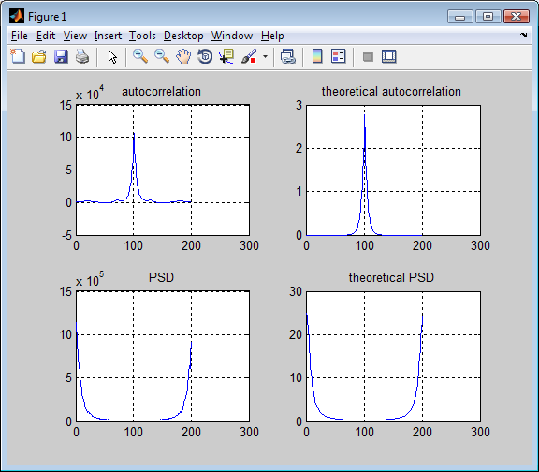

When we set it to be 2000

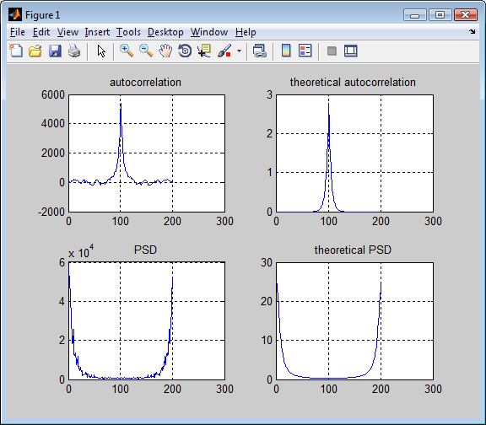

2. Source Code

clc;

clear;

x = randn(40000,1);load ydata; maxlags = 64;

ry = xcorr(y,maxlags)/length(y);

rx = xcorr(x,maxlags)/length(x);

sy = fftshift(abs(fft(ry)));

sx = fftshift(abs(fft(rx)));

h = sqrt(sy./sx);

t = -maxlags:1:maxlags;

f = (0:length(rx)-1)/length(rx)-0.5;

h_t=ifftshift(abs(ifft(h)));

figure(1)

subplot(2,2,1);

plot(t,rx);

title('input autocorrelation');

xlabel('time');

grid on;

subplot(2,2,2);

plot(f,sx);

title('input PSD');

xlabel('Freq');

grid on;

subplot(2,2,3);

plot(t,ry);

title('output autocorrelation');

xlabel('time');

grid on;subplot(2,2,4);

plot(f,sy);

title('output PSD');

xlabel('Freq');

grid on;

figure(2);

subplot(2,1,1);

plot(f,h);

title('|H(f)|');

xlabel('Freq');

grid on;

subplot(2,1,2);

plot(t,h_t);

title('h(t)');

xlabel('time');

grid on;

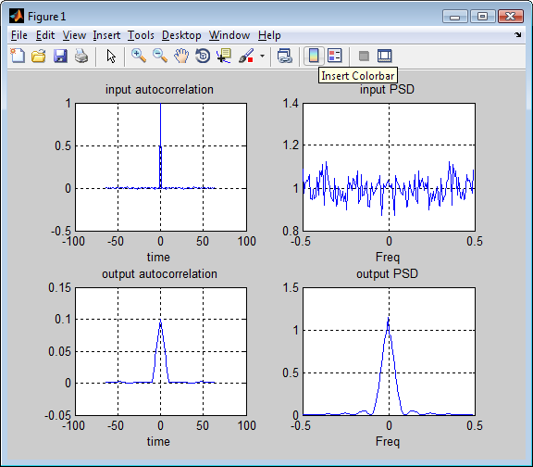

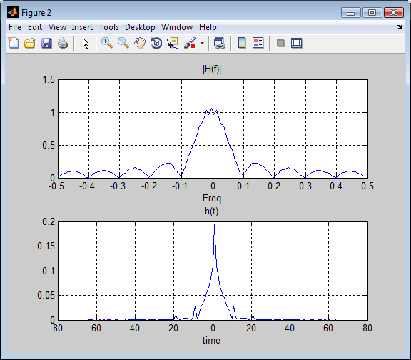

3. Source Code:

y = randn(40000,1);

Y = fftshift(abs(fft(y)));

f = (0:length(y)-1)/length(y)*1000;

figure(1);

plot(f-500,Y/length(y));

xlabel('f');

title('random noise');

grid on;

load part3;

figure(2);

X = fftshift(abs(fft(x)));

f = (0:length(x)-1)/length(x)*1000;

plot(f-500,X/length(x));

xlabel('f');

title('PSD');

grid on;

